Homogeneous Transformation Matrices

Coordinate Frames
Coordinate frames provide a way of representing rigid objects in three-space and the relationship between objects.
Points are represented via coordinates in an orthonormal right-handed coordinate system:

z = x × y

Fig. 5: Right Handed Coordinate System

A point P is written as:

P = 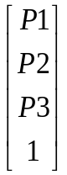

-where the '1' allows translation matrices to be formed which can be multiplied with the vector to translate it. This enables translation and rotation matrices to be combined via multiplication.

Generally, where there are two points, P and Q, P - Q is considered a vector.
If v is a vector, then P + v is considered a point.

Proper Rigid Motions
Proper Rigid motions are maps from ℜ³ to ℜ³ that preserve orientation and distances between points on a body. They can be represented by homogeneous transformations of the form:
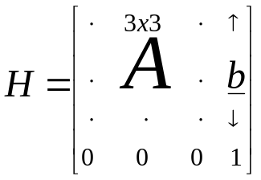

'A' is a 3x3 rotation matrix. It is an orthonormal matrix and so satisfies A⁻¹ = A^{T} and determinant(A) = 1.
'b' is an element of ℜ³.
The set of 4x4 matrices of this form under matrix multiplication is called the group of rigid motions on ℜ³.

A transform 'H' acts on a point P by:
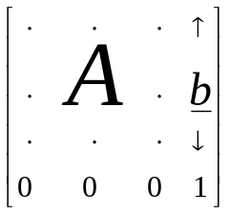 = 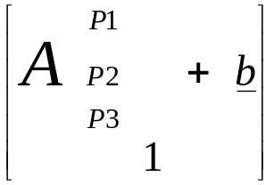
This can be interpreted as: first rotate P about the origin by A, then translate by b.

Homogeneous transformations can also be used to represent coordinate frames:

Fig. 6: Transformation Between Coordinate Frames

The transformation describing frame 1 in terms of frame 0 is:

T_{0,1} = 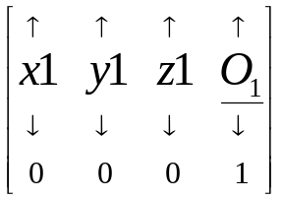

- x1, y1, z1 are the unit vectors of frame 1 in terms of frame 0. O₁ is the position of the origin of frame 1 in terms of frame 0.

If a point P is written in terms of frame 1, then:

P⁰ = T_{0,1}P¹

Thus, T_{0,1} converts the coordinates of P to be in terms of frame 0.

If 'T' is a transform, 'F' represents a frame, and P is a point written in that frame's coordinates, then:
- F x T x P is the transform effected in the frame coordinates; the position of the transformed point being in base coordinates;
- T x F x P is the transform effected in the base coordinates.
The above example shows how homogeneous matrices can be combined by multiplication. The transformation matrices are read in order from right to left. Thus, in the first case above, 'T' is enacted before 'F', and visa-versa in the second case.
A series of transformations can then be performed by multiplying them together starting from the right. The resulting matrix represents the combined effects of this series of transformations.

Inverse Transformations
If a transform 'T' is represented by a homogeneous matrix:

T =

then its inverse is simply:

T⁻¹ = 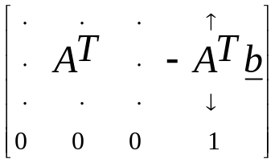

This is an efficient computational expression for T⁻¹ using the orthonormal property of A.

Denavit-Hartenburg Matrices and Parameterisation
For a serial link mechanism, a simple way of working out the forward kinematics is to embed a coordinate frame in each of the links and use homogeneous transformation matrices to describe the relative position and orientation between these coordinate frames.
The position and orientation of the first link, with respect to the base frame, can be described by T_{0,1}. Similarly, the position and orientation of the second link with respect to the first link is T_{1,2}. The relationship between the second link and the base coordinates is then T_{0,2} = T_{0,1}T_{1,2} by combining the frame matrices by multiplication.
Each T_{i,i+1} is called a Denavit-Hartenburg matrix.

The process can be continued up to the end-effector where the matrix T_{0,E} gives the position (4th column) and the orientation (A-matrix) of the end-effector in base coordinates.

A similar approach can be used for parallel-link mechanisms by converting them to an equivalent tree structure as described in the literature review.

To set up the coordinate systems and Denavit-Hartenburg matrices, a general representation can be used as follows:

Fig. 7: Denavit-Hartenburg Parameterisation [Kovesi96]

where:

Parameter | Symbol | Description
link length | a_{n} | Common normal between the joint axes of joints n and n-1.
twist angle | α_{n} | Angle that would exist between the joint axes if the origins of the joint frames were aligned.
joint angle | θ_{n} | Angle between the common normals of successive links a_{n-1} and a_{n}.
link offset | d_{n} | Distance along the axis of joint n (z_{n}), between the intersections of the common normals of the links with the joint axes.

The coordinate frame for joint n can then be set up:
- z_{n-1}, z_{n} - correspond to the respective joint axes as shown.
- The intersection of the common normal a_{n} and the axis z_{n} forms the origin for frame 'n'.
- x_{n} is aligned with a_{n}.
- y_{n} = z_{n} × x_{n.}

The transformation from one frame to the next is then given by:
T_{n-1,n} = Rotz(θ) Trans(0,0,d) Trans(a,0,0) Rotx(α)
Where:
Rotz(θ) - transformation matrix which represents a rotation about the z-axis by θ in the positive direction as dictated by the right handed coordinate system.
Trans(0,0,d) - translation by 'd' in the positive z-direction.
Trans(a,0,0) - translation by 'a' in the positive x-direction.
Rotx(α) - transformation matrix which represents a rotation about the z-axis by θ in the positive direction as dictated by the right handed coordinate system.

This series of transformations can be read from right to left, where each transformation would be enacted in the base coordinate system; or it can be interpreted from left to right, where each transformation is enacted in the local coordinate frame which has been created by the previous transformations.

NOTE: the Denavit-Hartenburg parameter ,'α' (the twist angle), should not be confused with the other variable called 'α' which refers to one of the angles through which the motors are rotated (so as to alter the workspace of the NUWAR robot).

